Verbal CR - 2

https://www.facebook.com/events/404887863298689/

Remember people, in verbal we are as good as we read. moment we do not read properly, we are done for. I will keep introducing new strategies progressively.

Today let us undertand what is POE

Process of Elimination simply means that we ELIMINATE the wrong answer choice rather than choose. this will allow us to be come sure in our answers.

Study the following picture and then let us take the points

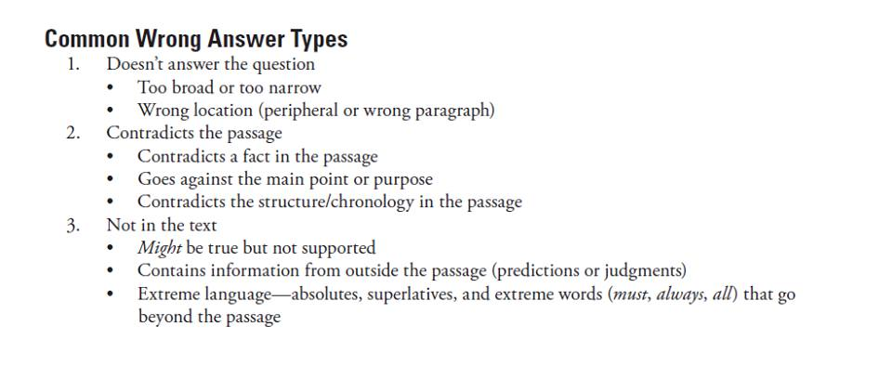

[#POE](https://www.facebook.com/hashtag/poe?source=feed_text). Extreme words

Suppose the author says that

customers and suppliers hide information from each other so as to derive more profit. customer does not tell his exact buying power and supplier does not tell his discount rate.

now given the passage what can we say about the relation between customer and supplier

1) they are skeptical about each other  
2) they are adversaries  
3) they are mutually beneficial  
4) they are opposed to savings

now 2 is an extreme choice. If they are withholding information, it does not meand they are adversaries.. that is extreme

OA: 1

Doesn’t answer the question  
• Too broad or too narrow

[ no option can enlarge the scope of the passage. if passage talks about India, option cannot talk about World.   
same is true for reverse of it)

• Wrong location (peripheral or wrong paragraph)  
this means that in an RC [not in CR] I should stick the location of the question being aksed. If the question asks what does the author mean about X which is given in the first para, i cannot pick answer from any other para]

Contradicts the structure/chronology in the passage

this is necessarily only structure question. this means that if the author is argumentative in his passage and you are asked HOW does the author create the para, then any answer that says the author is EXPLAINING or is DESCRIBing is wrong

or the author writes A >B > C .. and the option changes the sequence of the para or idea flow then .. the option is wrong

[#CR5](https://www.facebook.com/hashtag/cr5?source=feed_text&story_id=405112226609586)

> Might be true but not supported.

this option will add information from the outside which might be true in general sense but is not written directly or indirectly in the passage.

the gist of all the previous points is   
I will eliminate any option that

1) adds UNRELATED information. remember in some question we may choose an option that is not mentioned directly but can be derived from the passage. this kind of option is allowed

2) is extreme as per the passage

3) is too generalised

4) goes against the question

Remember friends, the correct answer HAS TO BE PROVABLE from the passage. wrong option will HAVE SOMETHING -a word , sometimes even a letter- which you CANNOT PROVE without assuming

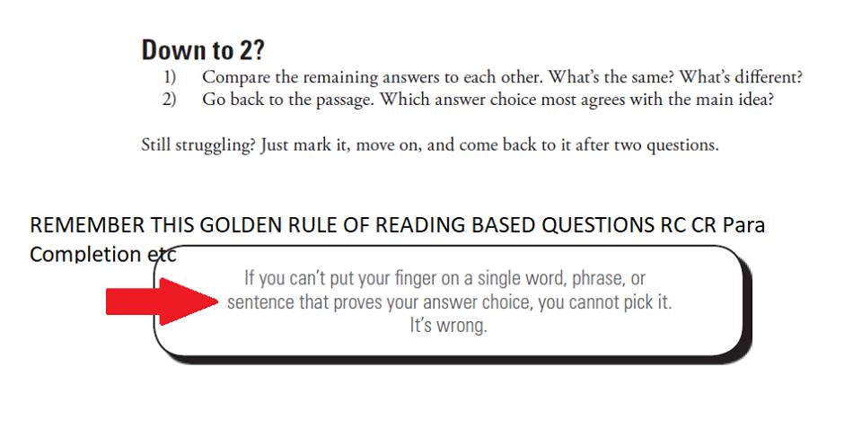

[#CRQ1](https://www.facebook.com/hashtag/crq1?source=feed_text&story_id=405120029942139) 2 mins

The sustained massive use of pesticides in farming has two effects that are especially pernicious. First, it often kills off the pests’ natural enemies in the area. Second, it often unintentionally gives rise to insecticide-resistant pests, since those insects that survive a particular insecticide will be the ones most resistant to it, and they are the ones left to breed.

From the passage above, it can be properly inferred that the effectiveness of the sustained massive use of pesticides can be extended by doing which of the following, assuming that each is a realistic possibility?

(A) Using only chemically stable insecticides  
(B) Periodically switching the type of insecticide used  
(C) Gradually increasing the quantities of pesticides used  
(D) Leaving a few fields fallow every year  
(E) Breeding higher-yielding varieties of crop plants

OA : b

[#CRQ1OA](https://www.facebook.com/hashtag/crq1oa?source=feed_text&story_id=405121939941948): B

A Not enough information about chemically stable insecticides is given to make a sound inference.

B Correct. This statement properly identifies an action that could extend the effectiveness of pesticide use.

C Gradually increasing the amount of the pesticides being used will not help the situation since the pests are already resistant to it.

D Continued use of pesticides is assumed as part of the argument. Since pesticides would be unnecessary for fallow fields, this suggestion is irrelevant.

E Breeding higher-yielding varieties of crops does nothing to extend the effectiveness of the use of pesticides.

[#CRQ2](https://www.facebook.com/hashtag/crq2?source=feed_text&story_id=405123209941821) 2 mins

In an attempt to promote the widespread use of paper rather than plastic, and thus reduce nonbiodegradable waste, the council of a small town plans to ban the sale of disposable plastic goods for which substitutes made of paper exist. The council argues that since most paper is entirely biodegradable, paper goods are environmentally preferable.

Which of the following, if true, indicates that the plan to ban the sale of disposable plastic goods is ill suited to the town council’s environmental goals?

(A) Although biodegradable plastic goods are now available, members of the town council believe biodegradable paper goods to be safer for the environment.  
(B) The paper factory at which most of the townspeople are employed plans to increase production of biodegradable paper goods.  
(C) After other towns enacted similar bans on the sale of plastic goods, the environmental benefits were not discernible for several years.  
(D) Since most townspeople prefer plastic goods to paper goods in many instances, they are likely to purchase them in neighboring towns where plastic goods are available for sale.  
(E) Products other than those derived from wood pulp are often used in the manufacture of paper goods that are entirely biodegradable.

[#CRQ2OA](https://www.facebook.com/hashtag/crq2oa?source=feed_text) : D

A The existence of biodegradable plastic does not make the town’s plan to ban disposable plastic goods unsuitable to its environmental goal, which is to reduce nonbiodegradable waste.

B That the local factory will increase production of biodegradable paper goods makes it more likely that a sufficient amount of such products will be available for townspeople who wish to switch from disposable plastic goods, so this does not indicate that the council’s plan is ill suited for its goals. and is it necessary that availablility of a product ensures it adoption

C Environmental benefits need not be immediate. Even though benefits were not perceived for several years after similar bans, the benefits did occur. and secondly why are we using other town's data. are these towns identical

D Correct. This statement properly identifies the problem with the council’s plan.

E The specific materials that go into making nonbiodegradable paper are not in question. This statement is irrelevant to the plan.

[#CRQ3](https://www.facebook.com/hashtag/crq3?source=feed_text&story_id=405126719941470) 2 mins

In the past five years, there has been a marked decline in the consumption of soft drinks sweetened with sugar. During the same time, there has been increasing publicity about the adverse health effects of weight gain caused by the consumption of sugar-laden drinks. Clearly, the public’s awareness of the harmful health effects of weight gained by consuming sugar-laden drinks caused the decline in the consumption of  
such drinks.

Which of the following, if true, most stengthens the  
argument above?

A . Many consumers have switched to drinking diet soft drinks which are not sweetened with sugar.

B. The average person’s consumption of soft drinks sweetened with sugar has decreased by 8.2 ounces per day.

C. Consuming large quantities of sugar laden drinks has also been linked to mood swings throughout the day.

D The consumption of packaged cookies which feature sugar as a key ingredient has decreased during the time period in question.

E. The price of sugar-laden soft drinks has remained stable for the past five years.

[#CRQ3OA](https://www.facebook.com/hashtag/crq3oa?source=feed_text&story_id=405129069941235): E

the questions has two points

IF TRUE.. this means the option can be hypothetical  
MOST STRENGTHENS.. that means there can be two close options.. we need to chose the stronger one ]

the passage does a causal flaw. the author assumes that either there is only one factor that caused the decline or that other factors are neutral in this case.

this means we need to show that only publicity helped people decrease the intake

A . Many consumers have switched to drinking diet soft drinks which are not sweetened with sugar.

[ yes they have swtiched but does A explain WHY they switched. this option simply adds more data but actually does not prove that publicity or any other resulted in the decrease]

B. The average person’s consumption of soft drinks sweetened with sugar has decreased by 8.2 ounces per day.  
[same as A.. if the consumption has decreased .. WHY.. does it tell]

C. Consuming large quantities of sugar laden drinks has also been linked to mood swings throughout the day.  
[ LARGE quantities have been talked whereas the passage talks about decreased intake. secondly it shows that there is another factor .so it weakens ]

D The consumption of packaged cookies which feature sugar as a key ingredient has decreased during the time period in question.  
[ Same as A .. if the quantitey has decreased .. does D state WHY and if D is your answer, how do you elminiate A which is similar ]

E. The price of sugar-laden soft drinks has remained stable for the past five years

[ YES this is the ONLY OPTION WHICH IF TRUE shows tthat there is ANTOHER factor but that factor is not effective or instrumental in the decreaes ]

[#CRQ4](https://www.facebook.com/hashtag/crq4?source=feed_text&story_id=405134869940655) 2 mins [ I hope this will be done faster ]

Since the mayor’s publicity campaign for Greenville’s bus service began six months ago, morning automobile traffic into the midtown area of the city has decreased 7 percent. During the same period, there has been an equivalent rise in the number of persons riding buses into the midtown area. Obviously, the mayor’s publicity campaign has convinced many people to leave their cars at home and ride the bus to work.

Which of the following, if true, casts the most serious doubt on the conclusion drawn above?

(A) Fares for all bus routes in Greenville have risen an average of 5 percent during the past six months.

(B) The mayor of Greenville rides the bus to City Hall in the city’s midtown area.

(C) Road reconstruction has greatly reduced the number of lanes available to commuters in major streets leading to the midtown area during the past six months.

(D) The number of buses entering the midtown area of Greenville during the morning hours is exactly the same now as it was one year ago.

(E) Surveys show that longtime bus riders are no more satisfied with the Greenville bus service than they were before the mayor’s publicity campaign began.

[CRQ4OA](https://www.facebook.com/hashtag/crq4oa?source=feed_text) : C [please read the explanation thoroughly]

Argument: Traffic into midtown has decreased by 7 percent, and bus ridership has increased by an equivalent amount. The mayor’s publicity campaign is responsible for this change.

Reasoning What casts doubt on this conclusion? Another reasonable explanation of what caused the decrease in automobile traffic and the increase in bus ridership would make this conclusion suspect. Road construction impeding access to midtown over the same period of time is a reasonable alternative explanation. The road construction projects would likely have discouraged people from driving to midtown; many of these people have probably taken the bus.

A An increase in fares might be a reasonable explanation for a decrease in ridership, but not for an increase.

B The mayor’s decision to ride the bus sets a good example for citizens, so this would tend to strengthen rather than weaken support for the conclusion.

C Correct. This statement properly identifies an explanation that weakens support for the conclusion.

D If more buses were running, then more seats would be available for people traveling into midtown. Ruling out this scenario helps strengthen, not weaken, support for the conclusion.

E Passengers perceive bus service to be the same, so better service can be eliminated as a possible cause of the increased ridership.

The correct answer is C.

We had to find something else that would have been the reason for increased use of bus as a transport.